

Artificial Intelligence Lab 06 Tasks

**Name:** Alishba Waqar

**Sap ID:** 46997

**Batch:** BSCS-6th semester **Lab Instructor:** Ayesha Akram

**Task1. Solution:**

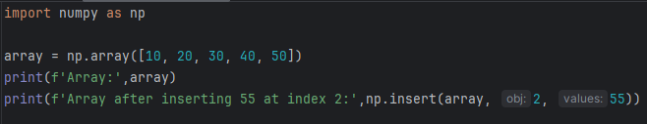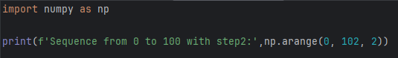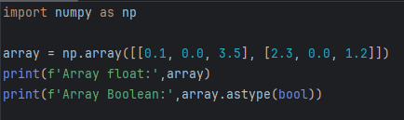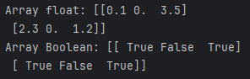

**Task2. Solution:**

**Task3. Solution:**

**Task4. Solution:**

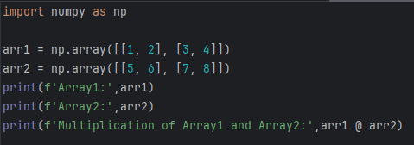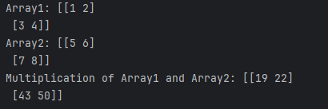

**Task5. Solution:**

